July 2026: Market Insight
Commentary:
July has been a volatile month with prices hitting the highest levels since March. Geopolitical tensions continue to dominate the headlines and prices have been supported with some concerns around long term storage. The current projection is for storage to be around 70% to 75% full which falls below the 80% target by the end of the year. It remains to be confirmed whether the storage level targets will be adjusted given the circumstances in the market so far this year.
Further escalations and attacks throughout the month saw front month prices rise by up to 40% . June had seen optimism of a ceasefire agreement being reached but the escalations throughout July have cast further doubt over the long term impact on prices. Traffic has rapidly decreased in the Strait of Hormuz again and LNG export from Qatar has returned to minimal levels.
UK and European weather has been above season norm for the majority of July, this does create extra cooling demand which does add some extra pressure to prices.
In adjacent markets, oil prices moved higher reaching weekly highs. Two oil tankers reportedly abandoned attempts to transit the Strait of Hormuz.
Inflation rates have held at 3.75% again despite the perceived risk in the markets.
Fundamental drivers
- European storage Still a fair way below the average storage levels for this time of year. Not currently on track for 80% target by end of the year.
- Norwegian flows Very stable in July within minimum disruption.
- Geopolitics The conflict in Iran remains the main driver due to the knock on effect with production and transportation of LNG. Peace talks are still ongoing but perhaps with less optimism now than in previous months giving the escalations in conflict again.
- Temperatures July has been a hotter than average month compared to season norm weather patterns. The good weather is forecast to continue into August and September. This will have an impact on cooling demand, however this can be balanced out by the fact the good weather can also help with storage injections.
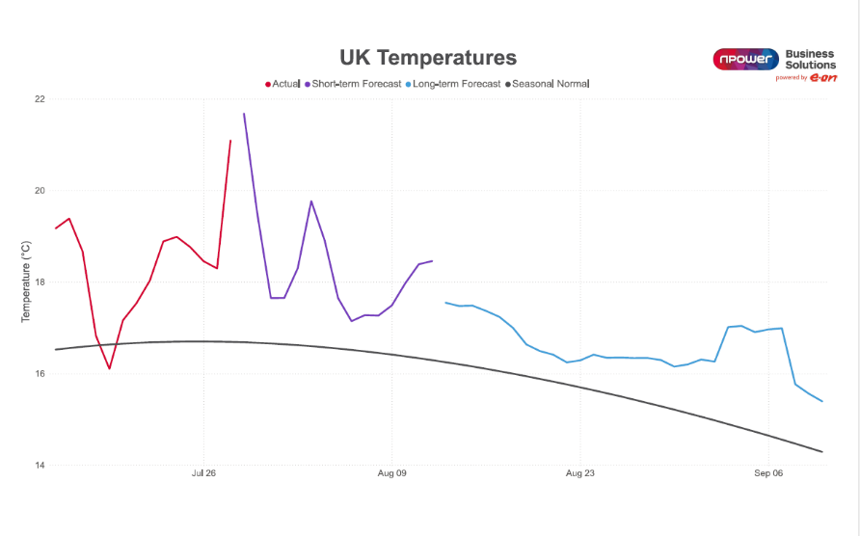
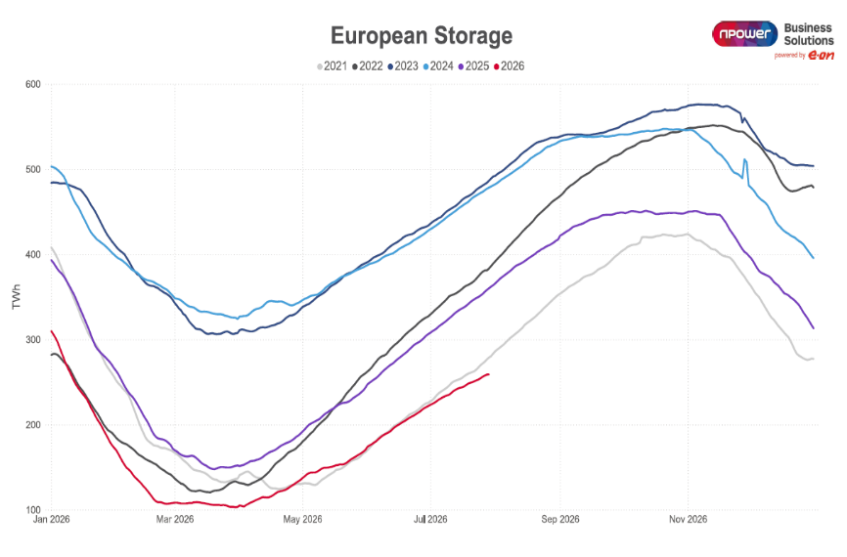

Markets – Day Ahead Price History
UK Gas: UK Power:
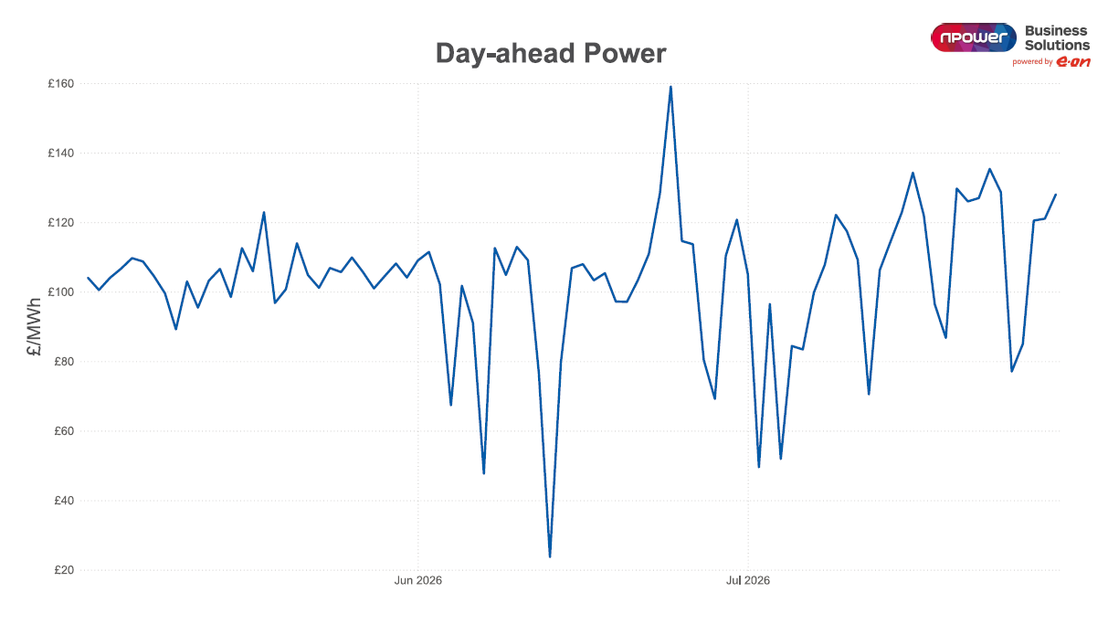
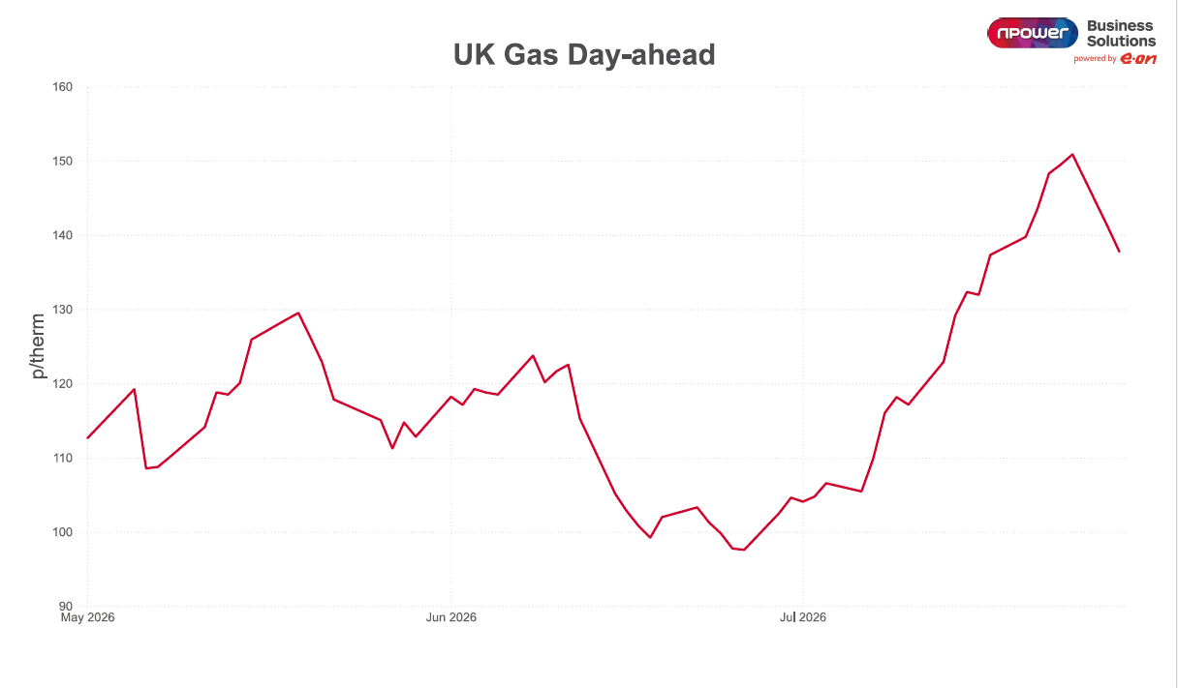

Outlook
Looking ahead, the market is likely to remain reactive to developments in global gas supply, geopolitical tensions, and the progress of storage injections across Europe. While softer summer demand and stronger renewable generation may continue to cap near-term volatility, the broader outlook remains finely balanced. For customers, this reinforces the importance of keeping a close eye on market opportunities and maintaining a clear procurement strategy, particularly where contracts are due for renewal over the coming months.

From a commercial perspective, the market continues to present both risk and opportunity. While stronger renewable generation and softer seasonal demand may help contain short-term volatility, customers should remain alert to any movement in gas supply, storage progress or geopolitical developments that could quickly shift pricing. For organisations approaching renewal, maintaining a clear purchasing strategy and being ready to act on favourable market windows will remain key to managing budget exposure over the months ahead.

